What I need the program to do:

Read the following from the excel spread sheet:

supplier | Manufacture part number  (Input) | Description  (Output) | QTY needed  (input) | Supplier code  (Output from website) | Cost  (output) | Stock  Available  (output) | MOQ minimum order quantity  (output)
Digikey
Farnell

All inputs are manually inputted, all outputs are what the program must get for us from the websites.
We have log in details needed to get our trade prices on these websites so must be able to login to get the discounted prices
So from excel the program would read the manufacture part number and qty needed and get the rest of the information populated using the program
Here is what I want the program to do automatically

Process
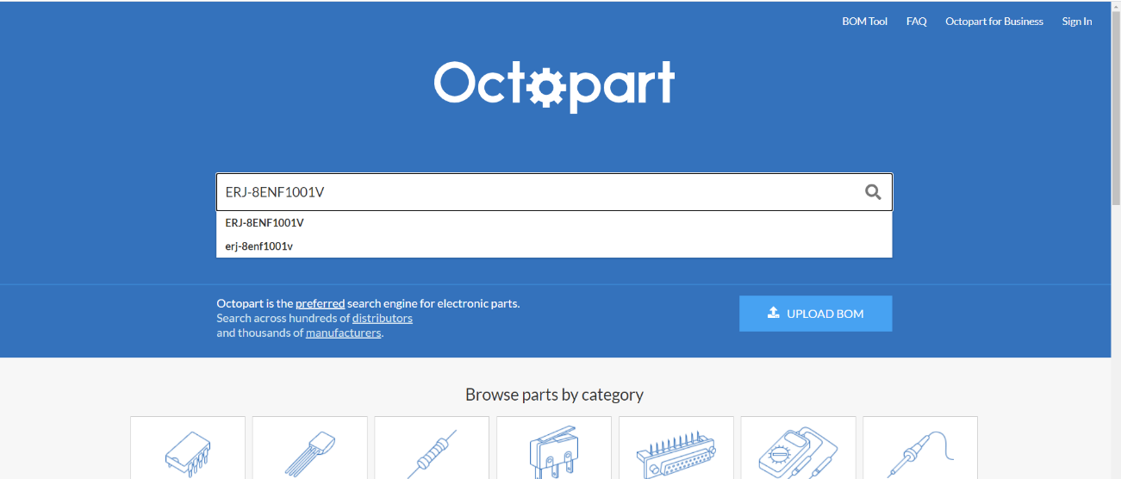
- Type manufacture part number into octopart as shown and click search

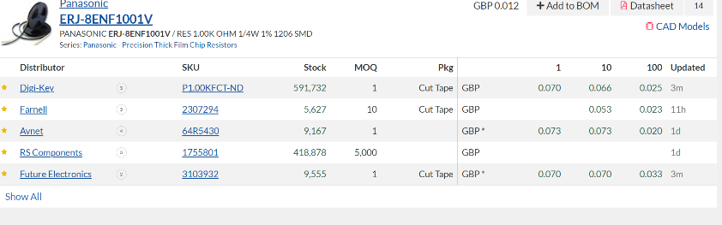
- Take stock value and MOQ value and packaging type for Farnell and digikey (from octopart)

- Click on digikey and Farnell hyperlink to go
to the corresponding websites. Autologging in with my email details to get the discounted rate available to me on my login

- Here is digikey website, need program to read how many we need columb 2 of table above, go to price bracket and select the correct bracket price depending on the qty needed. Remembering we need to be logged into the website to get the correct pricing.

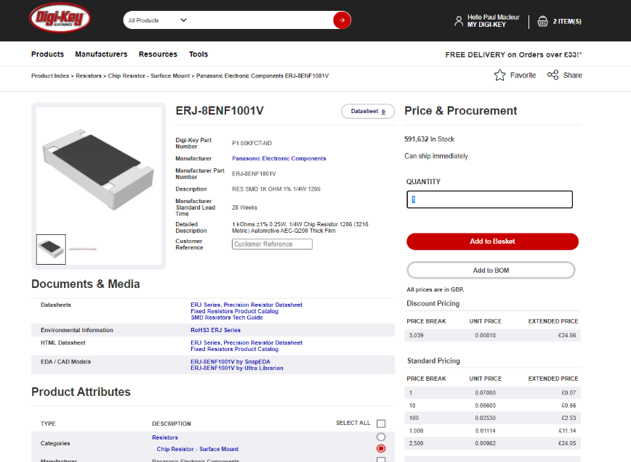

- Here is digikey website, need program to read how many we need (columb 2 of table above), go to price bracket and select the correct bracket price depending on the qty needed. Remembering we need to be logged into the website to get the correct pricing. Therefore if we need 120 qty then it will take price of 100 which is 0.02530 on the website. If I had 3040 needed then would take the discount pricing above at unit 0.00818 instead.
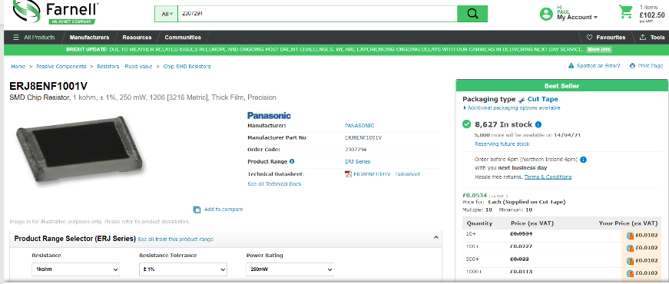

- Here is Farnell website, as you can see the pricing is different on here we usually just have one trade price for all the brackets except the higher quantities (1500+) we need to be logged in to see these discounted trade prices.

From these 2 websites I could fill the following data into the table 1

supplier | Manufacture part number  (Input) | Description | QTY needed  (input) | Supplier code  (Output from website) | Cost | Stock  Available | MOQ minimum order quantity
Digikey | ERJ-8ENF1001V | RES SMD 1K OHM 1% 1/4W 1206 | 50 | P1.00KFCT-ND | 0.06600 | 591,632 | 1
Farnell | ERJ-8ENF1001V | SMD Chip Resistor, 1 kohm, ± 1%, 250 mW, 1206 [3216 Metric], Thick Film, Precision | 50 | 2307294 | 0.0102 | 8627 | 10

